**Getting Started with Statistics**

Assignment 2.2

Q1: If the scores for a given sample distribution are:

32 32 35 36 37 38 38 39 39 39 40 40 42 45

Find the Variance and The Standard Deviation.

A1: Variance = 12.38, Standard Deviation = 3.52

Q2: The following table shows percent variations of two financial indices, the NYSE (New York Stock Exchange) and the NASDAQ composite (National Association of Securities Dealers Automated Quotation) in 10 consecutive days:

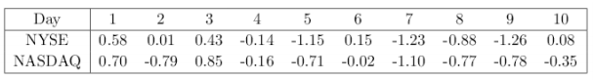

Use a suitable measure to quantify the dependence between the variations of the two indices and comment on the result.

A2: We can quantify the variation by calculating Covariance & Correlation of these two indices:

COV (NYSE, NASDAQ) = 0.35

COR (NYSE, NASDAQ) = 0.82

As we can see that both the values are positive so we can conclude that they move together in the same direction, meaning if NYSE increases NASDAQ will increase too & vice-versa.